***Web Development 2 Assignment Documentation 2017/2018***

A document that:

* lists the PHP pages used in your application – including a textual description of each page stating what the page does and how it interacts with other pages
* contains a copy listing of your source code (.php , .html) .
* contains a copy sample of each screen as it appears in   
  your application
* design document

# The listings of the PHP pages used in my application

1. The Login page (aka login.php)

This page allows you to log into the systems website. The page itself checks if you are a valid user already registered on the website. Through only this are you able to access the content of the application. If you are not registered, you cannot access the system through this way. However, there is a way which you can registered by clicking on the link in the top right-hand corner. This will lead you to the registering page. When you successfully logged in, it will redirect you to the home page. However, if you are already logged in and you try to log in again, it will redirect you to the home page. The details it takes in are your username and password. It checks the database if your username is on it. If this returns positive then it will return whether your password is a match. If it does not, you will not get access to the website.

1. The registering page (aka register.php)

This page will allow you to register in the website system. The page checks if you have the length of your password correct and your mobile number length correct. To make sure you entered your password correct, you need to enter it twice. If you try to take a username already in use, it will throw an error stating the username is already taken. If you are already a member, there is a link in the top right-hand corner which you can use to log into the system. If you try to access this page and already logged in, it will redirect you to the home page. Once you are registered, it will direct you to the home page. The details it takes from you are your first name, surname, street address, mobile number, telephone number and password (twice). It also takes a unique username from you.

1. The Home page (aka home.php)

This page will allow you to access four different pages depending on your choice. However, the first thing it does is checks if you are already logged in. If you are not, you are redirected to the login page. Your choices are to look up available books on the website, to reserve a book and to look at your reserved books. Once all that is completed, you can log out in the same way as searching for the other pages. All the choices are displayed in a dropdown list. If you want to search for a book, it will direct you to a search page which allow you to search for a book by category or by book title/author name. If you want to look at reserved books, it will send you to the page that displays all the books you have reserved. If you want to reserve a book, it will send you to a page that display all the books and takes in the ISBN number of the book which you want. Since it is the main page, you cannot access any other page through this page.

1. Search page (aka search.php)

This page takes the choice of the user of how they want to search for the book. There are two main ways, known as Book title/Author name or by category, of which either can be picked from a dropdown menu. The page checks if you are already logged in. If you are not, you will be directed to the login page. The form takes in the information of where the user wants to go from there. Once the person has entered what page they want, the information is sent to searching.php. This page basically sends you to the page where it displays the search method desired by the person. If the person wants to get back home, there is a link on the right-hand corner which allows them to return to the home page.

1. The Category Search page (aka category.php)

This page allows you to search for a book(s) based upon their category. The page itself checks if you are already logged in. If you are not, you are redirected to the login page. If you accidently chose this option, there is a link to go back to the search page. Alternatively, you can also return to the home page by clicking on the link next to the link that returns you to the search page. The page has a dropdown list of the categories which you pick one and send it through its interior php code. The results would be the database returns the books and all the data associated with them which are in that category for you to see.

1. The Book Title/ Author name Search page (aka book_title_author.php)

This page allows you to search for a book(s) based upon the Book Title or Author name. The page itself checks if you are already logged in. If you are not, you are redirected to the login page. If you accidently chose this option, there is a link to go back to the search page. Alternatively, you can also return to the home page by clicking on the link next to the link that returns you to the search page. The page has a textbox in which you type into and send it through its interior php code. The results would be the database returns the books and all the data associated with them which have that title or that author name for you to see.

1. Reserving a book page (aka reserving2.php)

This page allows you to reserve a book by its ISBN number. If you are not logged in, the page will redirect you to the login page. To make things easier, the page displays the books (Which with their ISBN number beside them and are currently not reserved). You can go back to the home page by clicking on the link on the right-hand side near the top. You can type the ISBN number of the book which you want to reserve. Once you submit that, the book is under your name and it tells you that the book has been reserved.

1. Looking at reserved books (aka reserved.php)

This page allow you to look at the books you have reserved. If you are not logged in, the page will redirect you to the login page. This ses your username to find the book which has been reserved under your name. It will return all the books you have reserved to display. Once you are done, You can go back to the home page by clicking on the link on the right-hand side near the top.

1. Database php

This connects to the database and makes sure every needed to run the programme goes smooth.

1. login.php (code first then webpage)

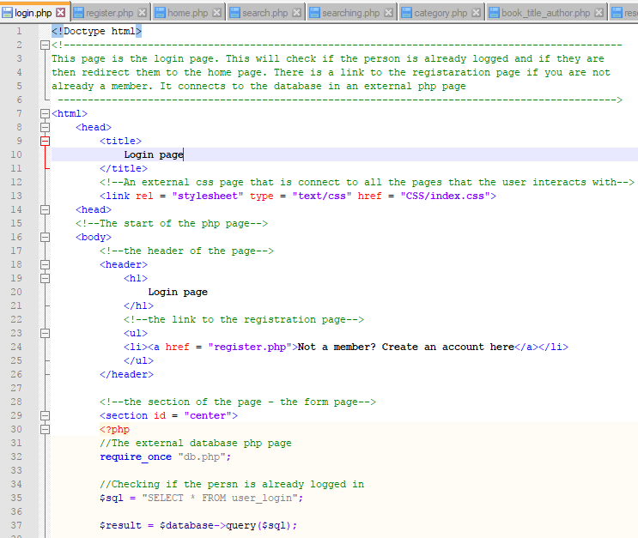

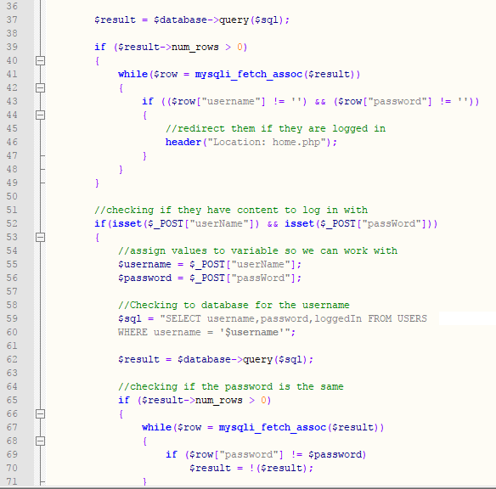

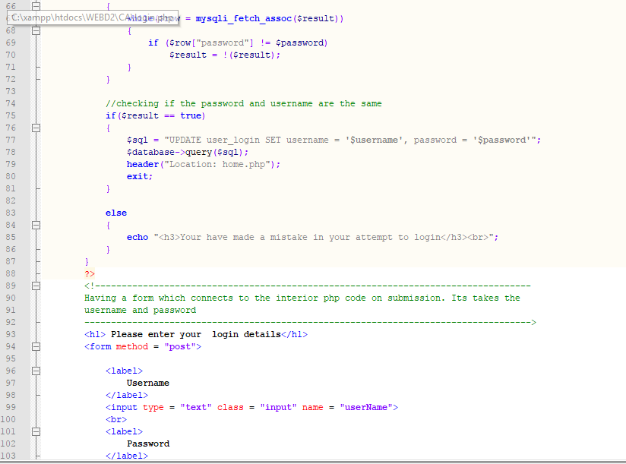

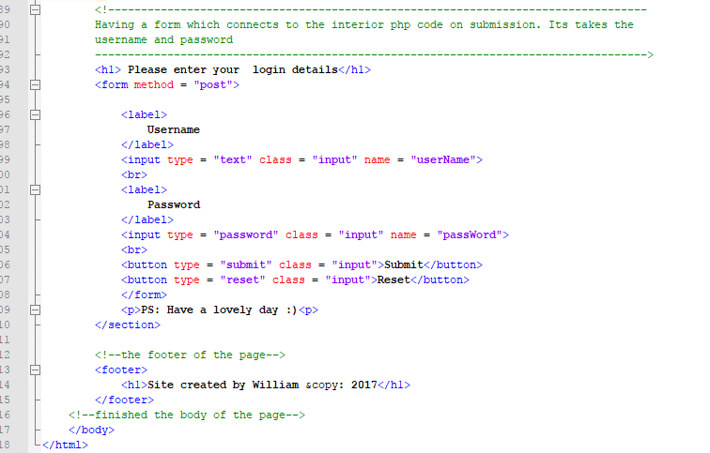

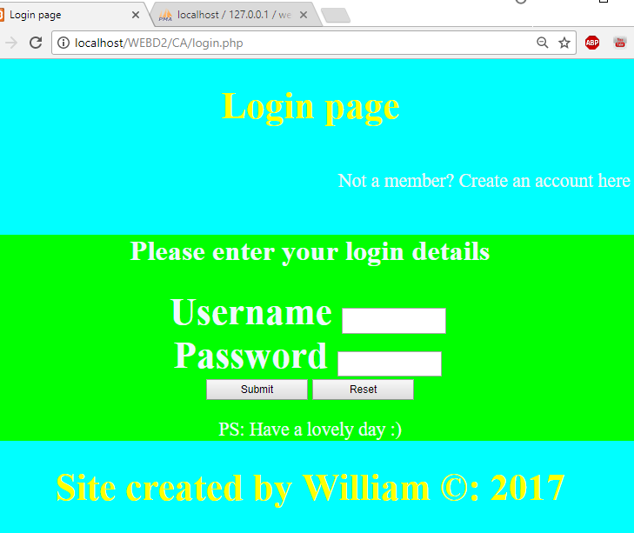

1. register.php (code first then webpage)

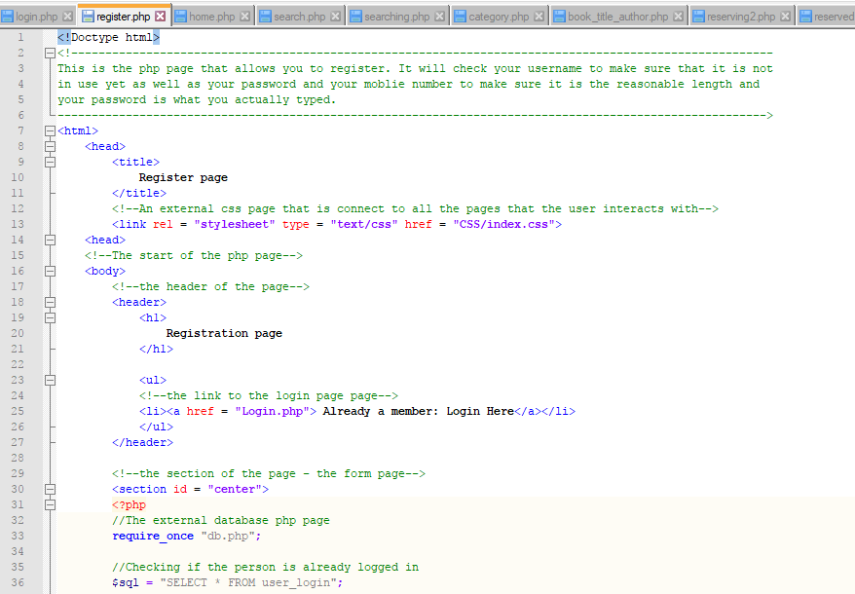

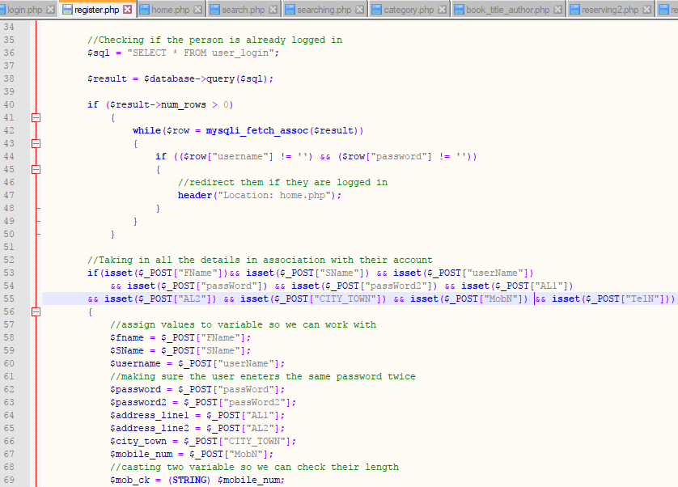

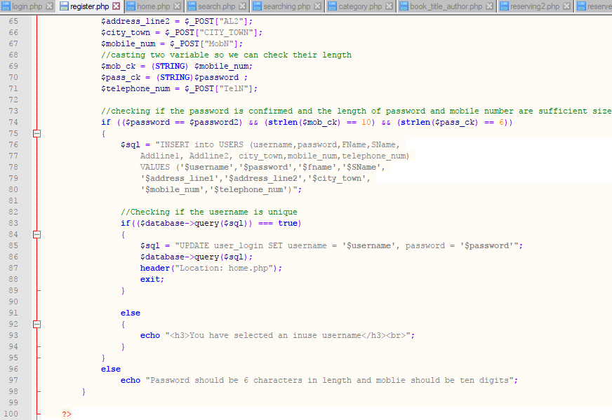

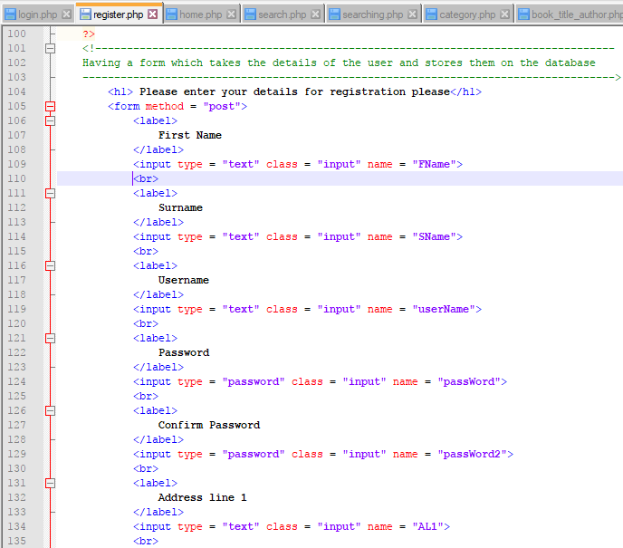

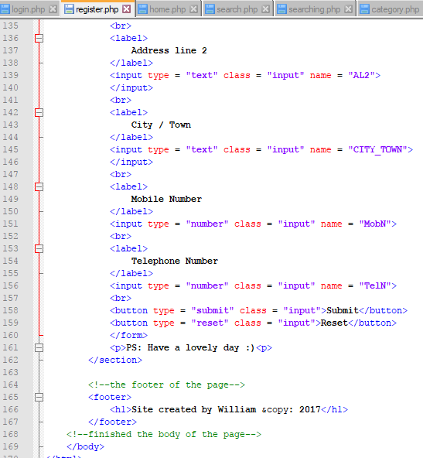

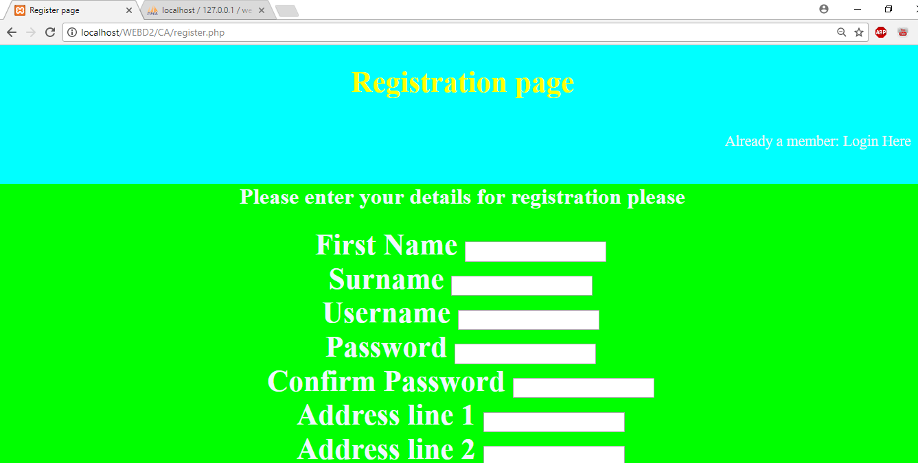

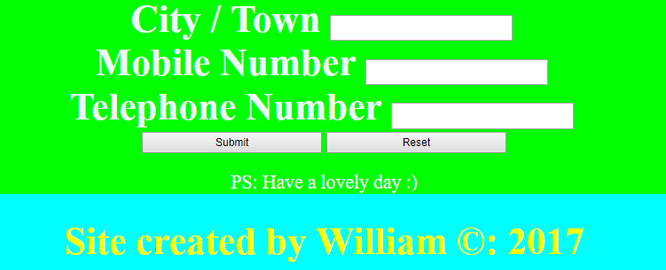

1. home.php (code first then webpage)

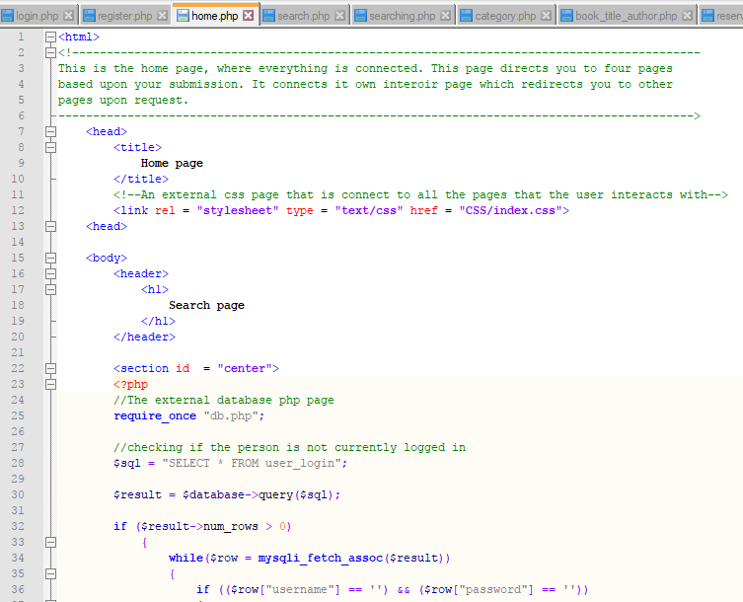

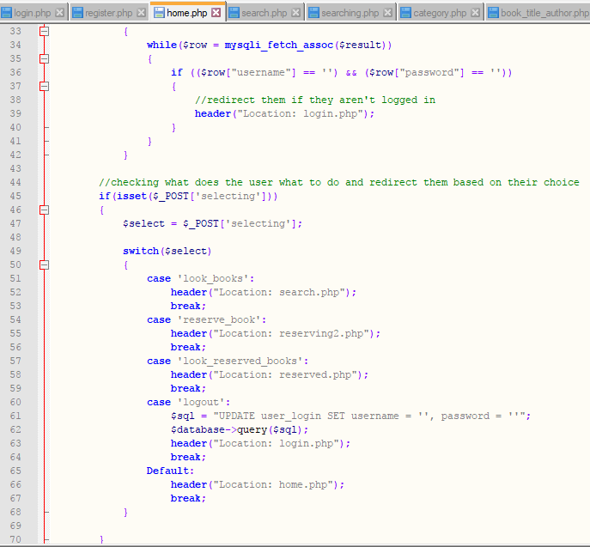

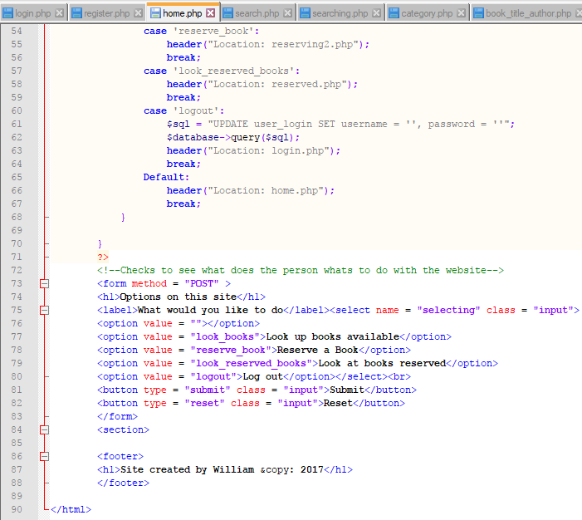

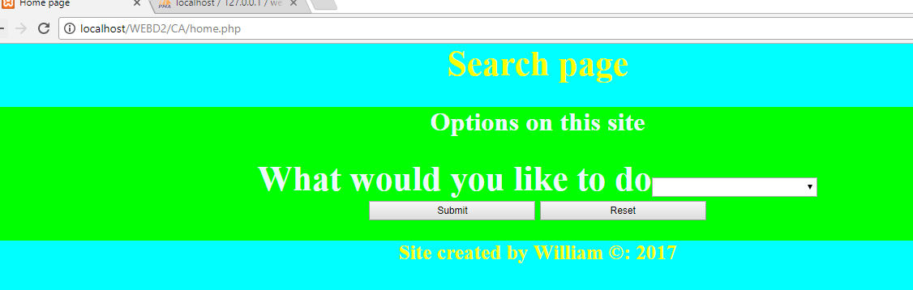





1. Search.php (code first then webpage)

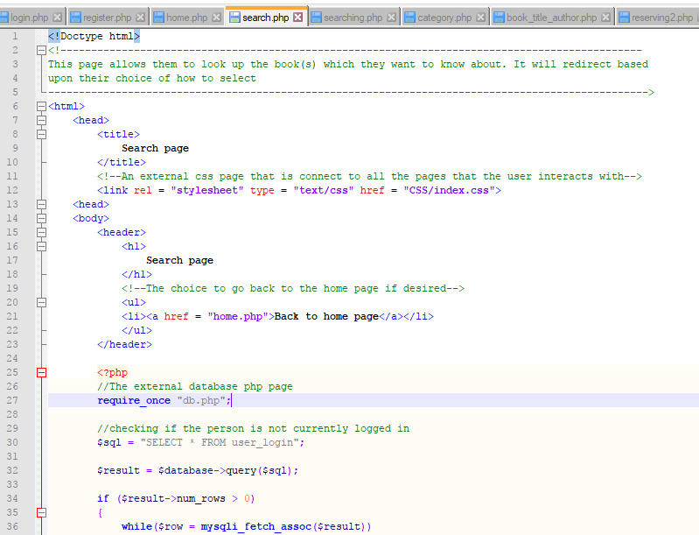

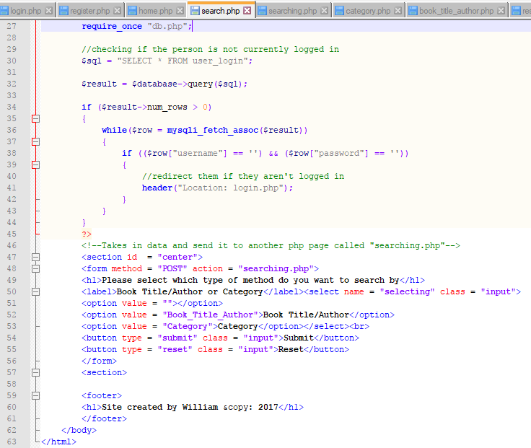

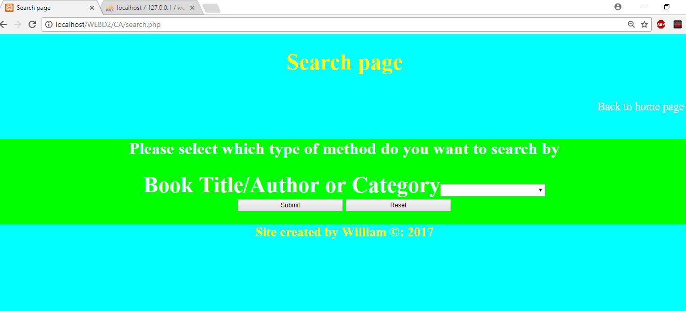

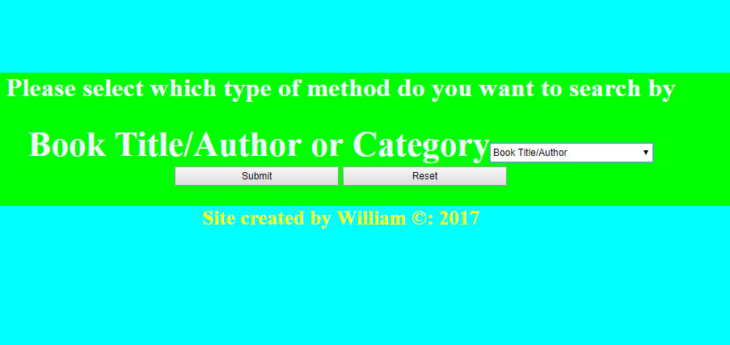

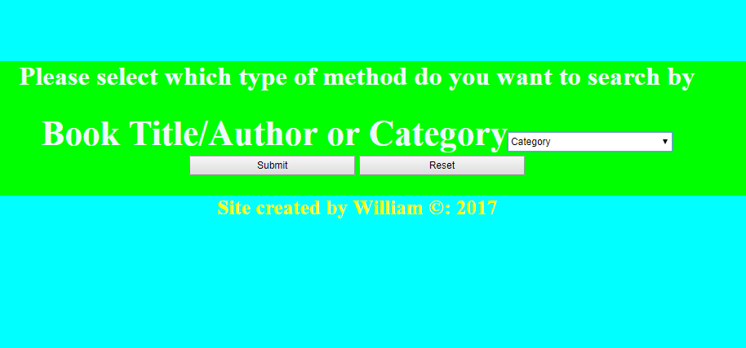

1. Searching.php (code first then webpage)

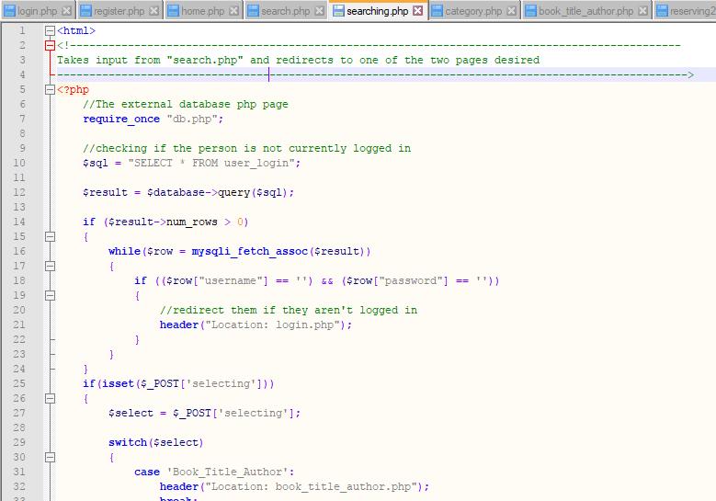

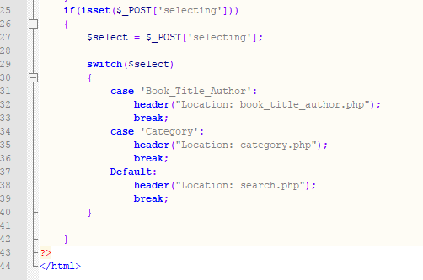

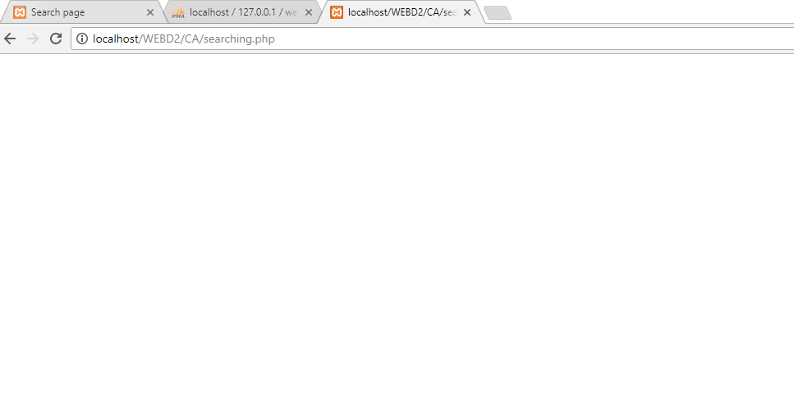

(No kidding – searching.php just redirects immediately after being called)

1. Category.php (code first then webpage)

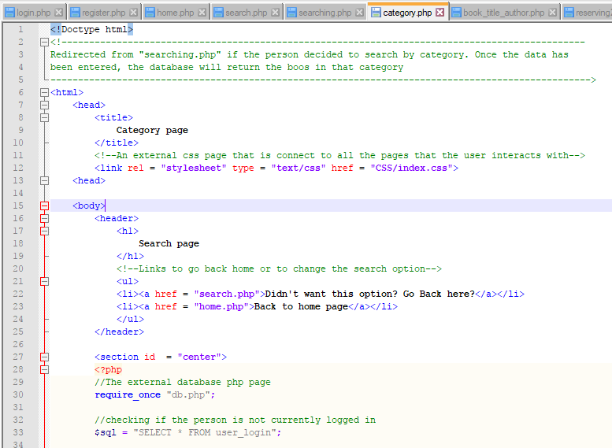

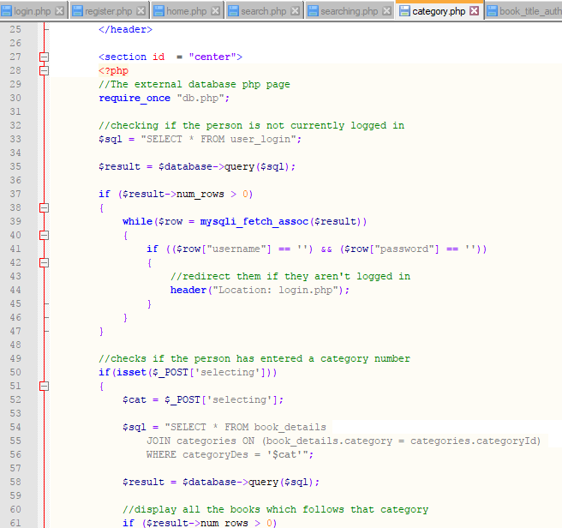

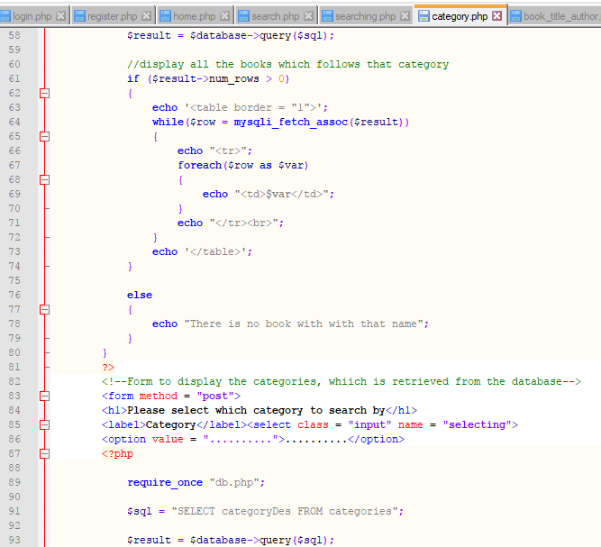

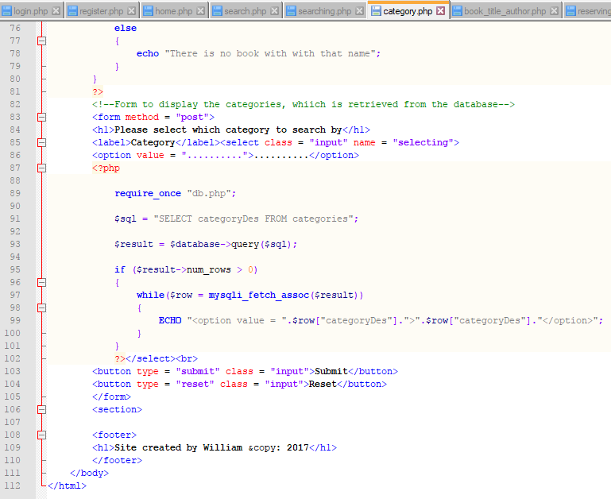

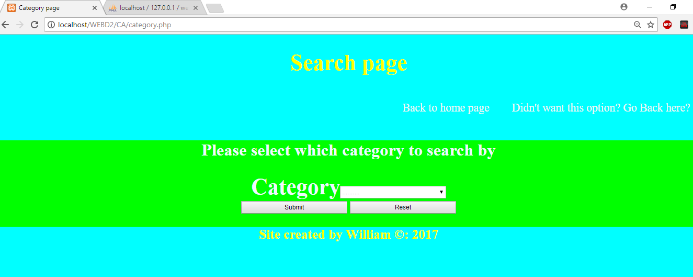

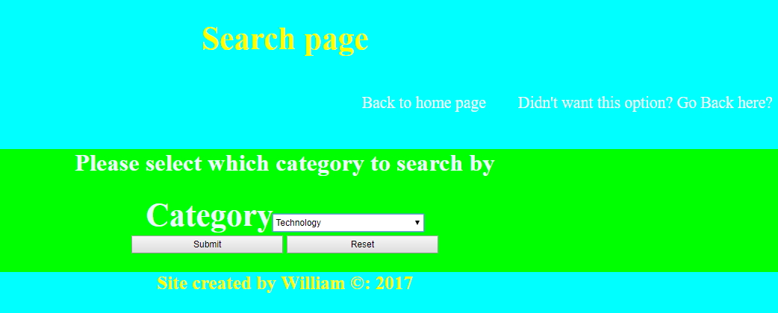

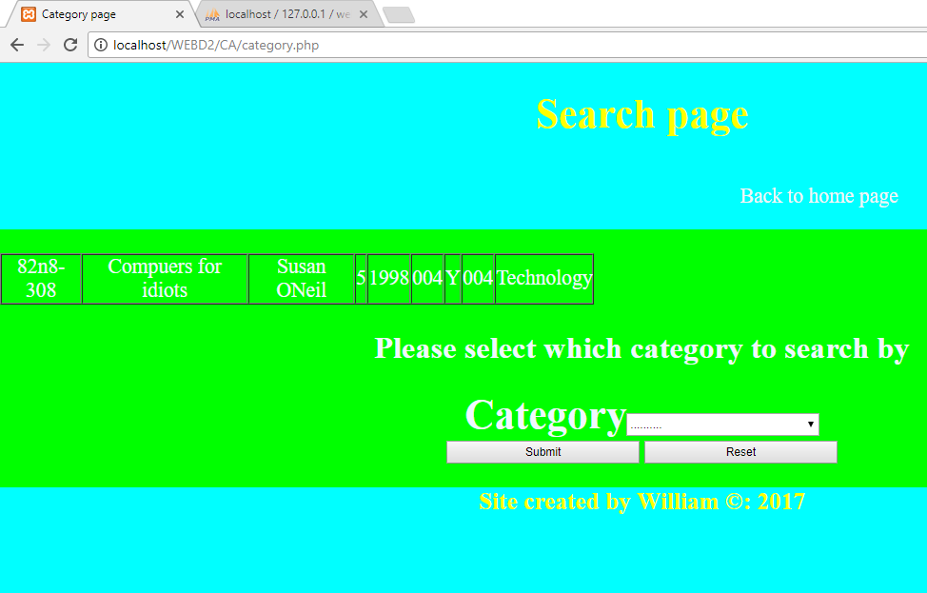

1. Book_title_author.php (code first then webpage)

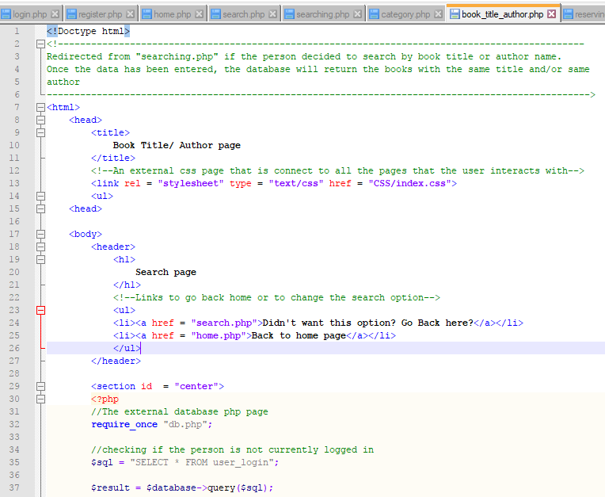

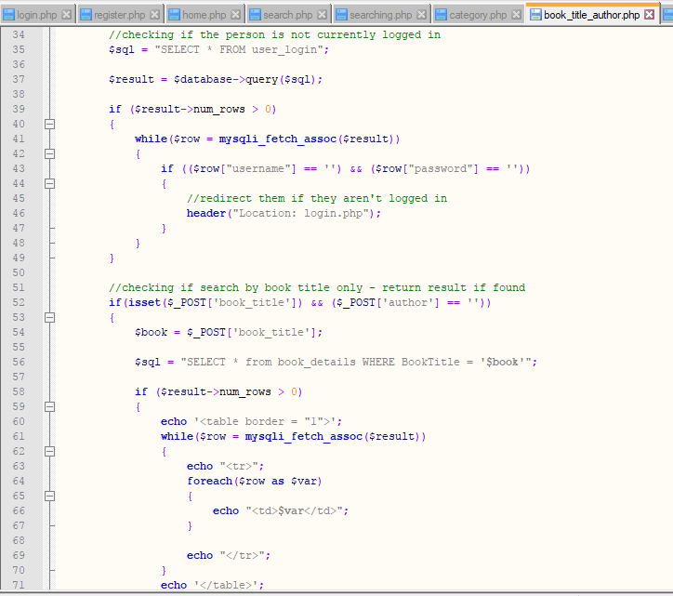

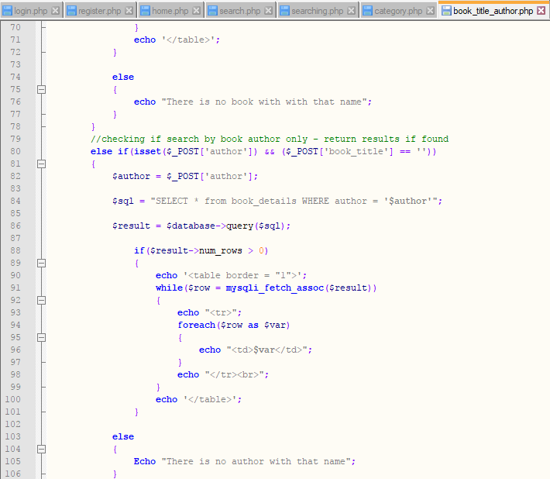

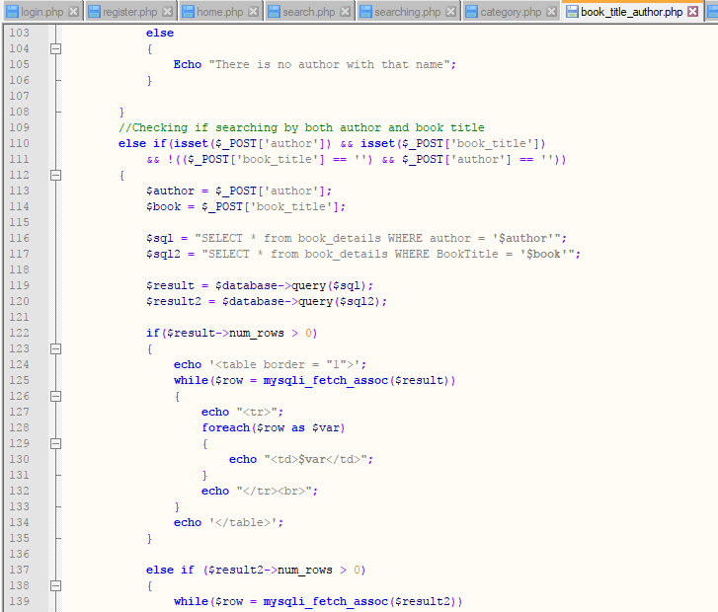

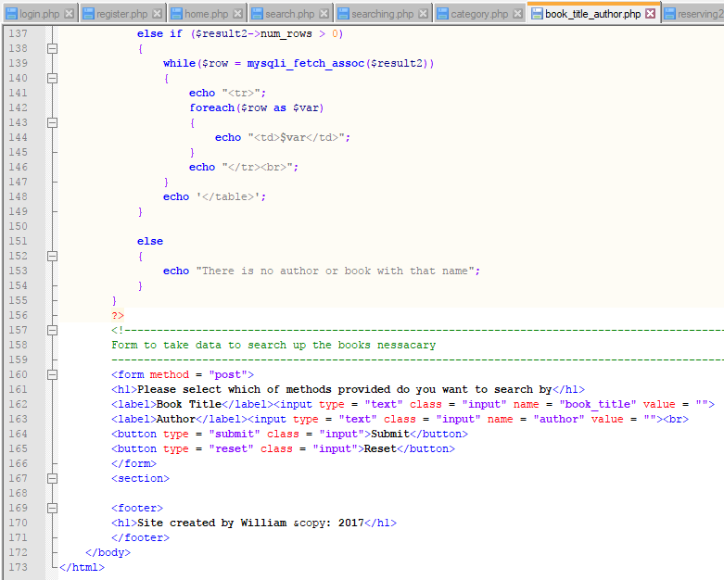

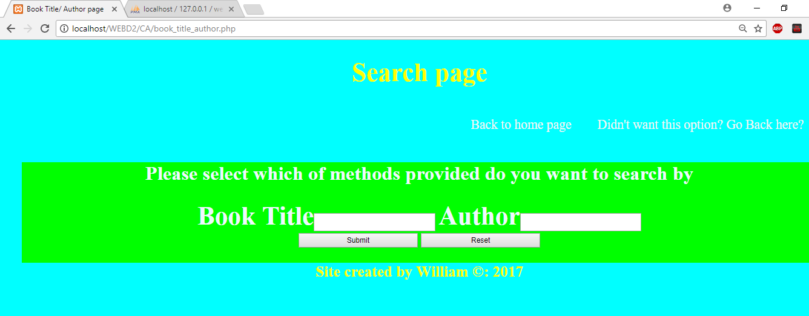

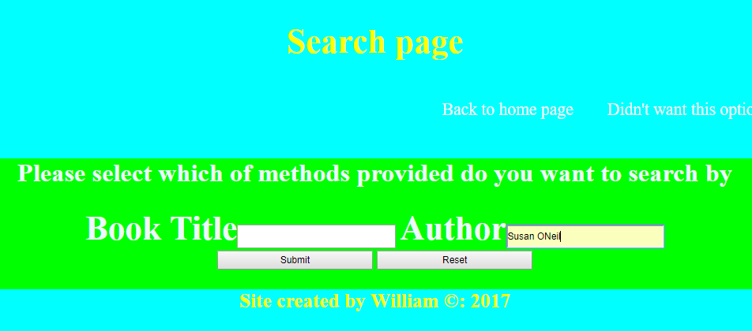

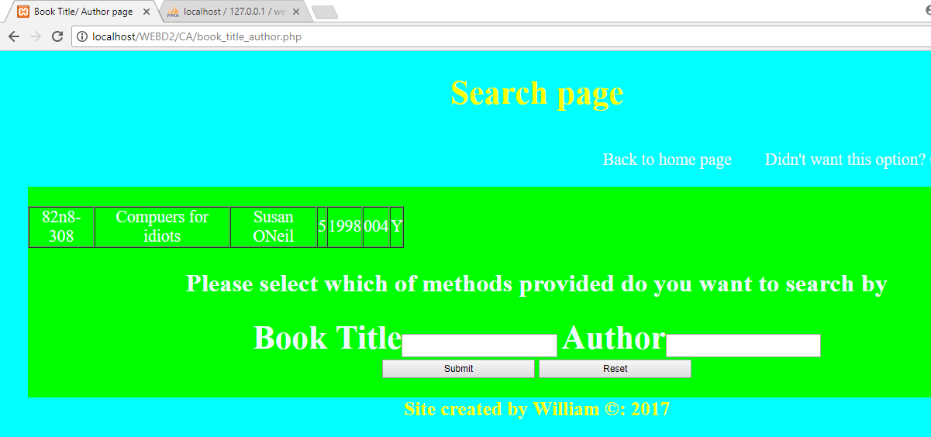

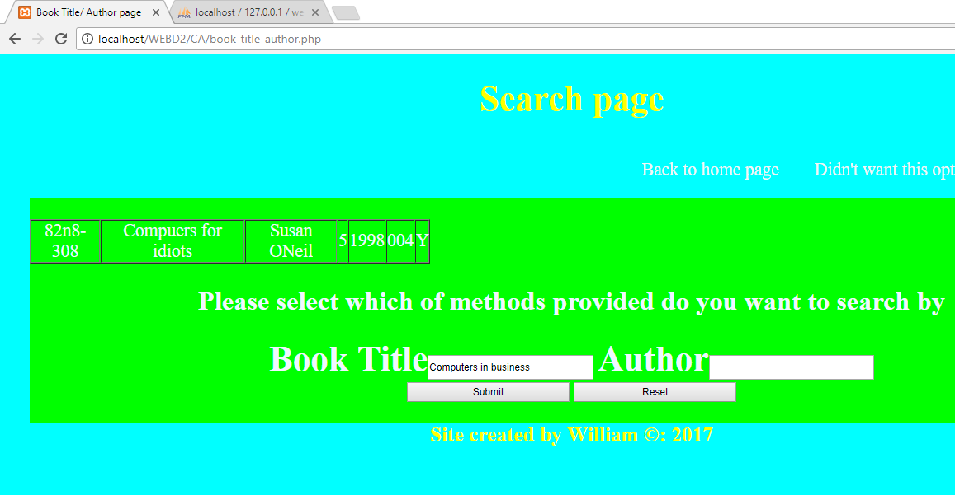

1. Reserving2.php (code first then webpage)

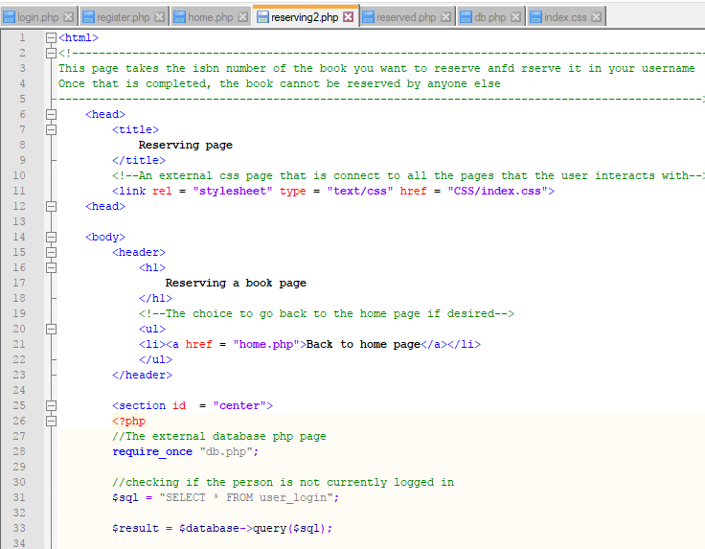

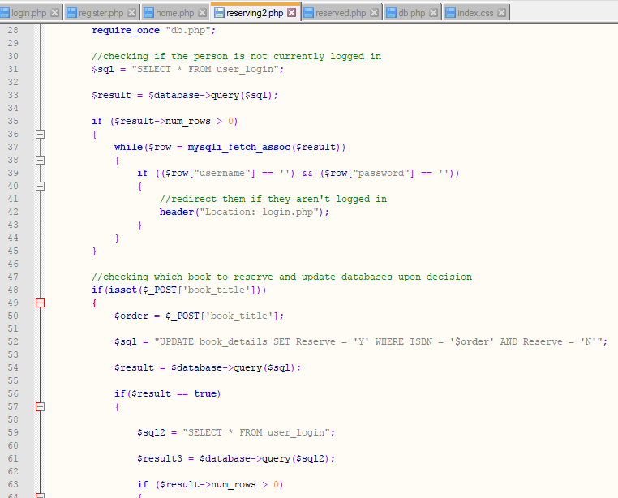

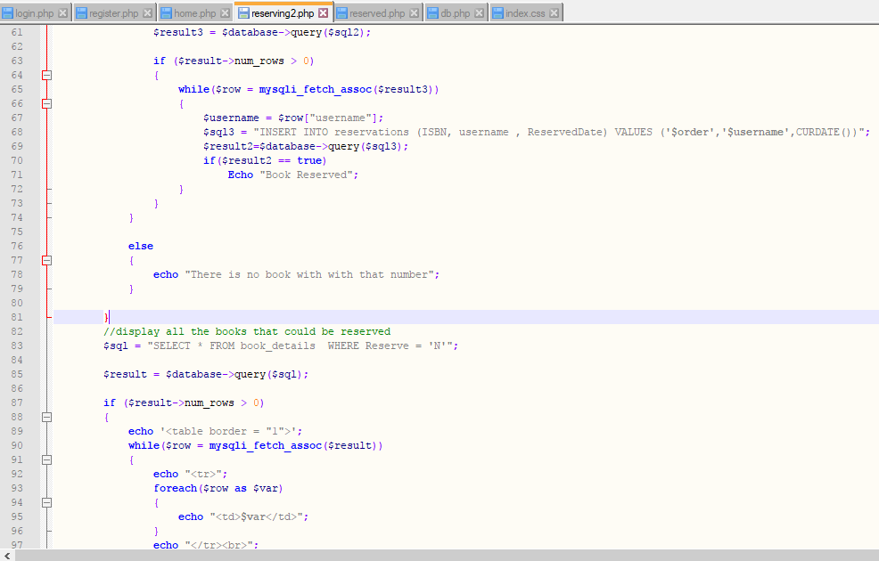

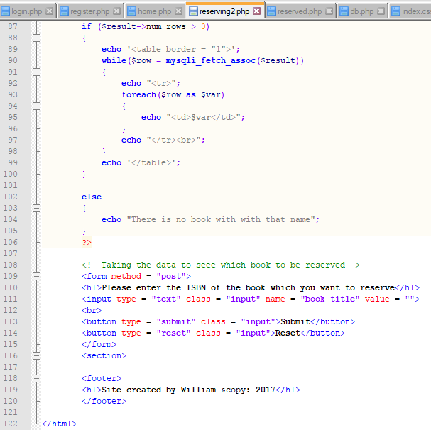

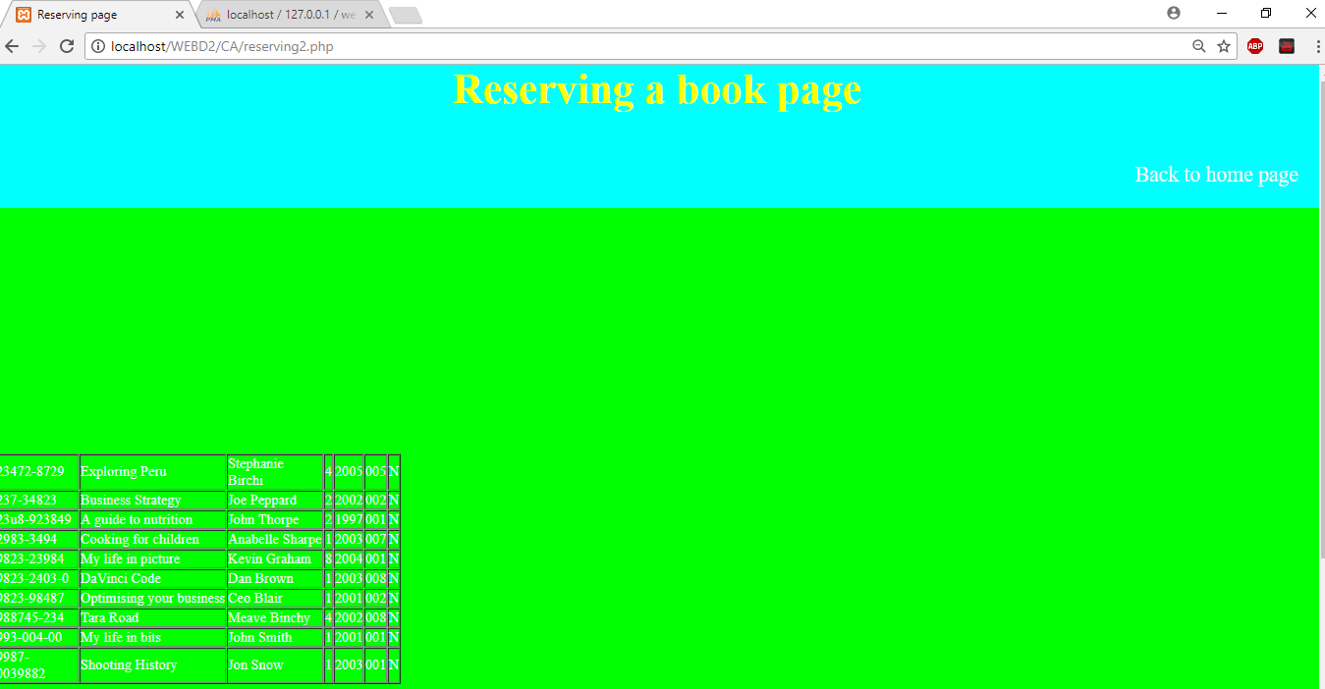

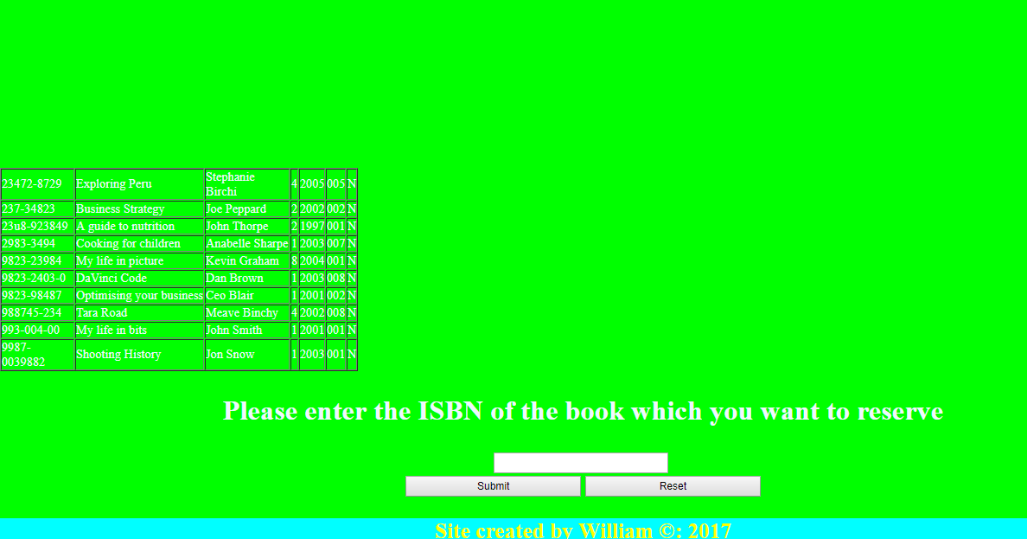

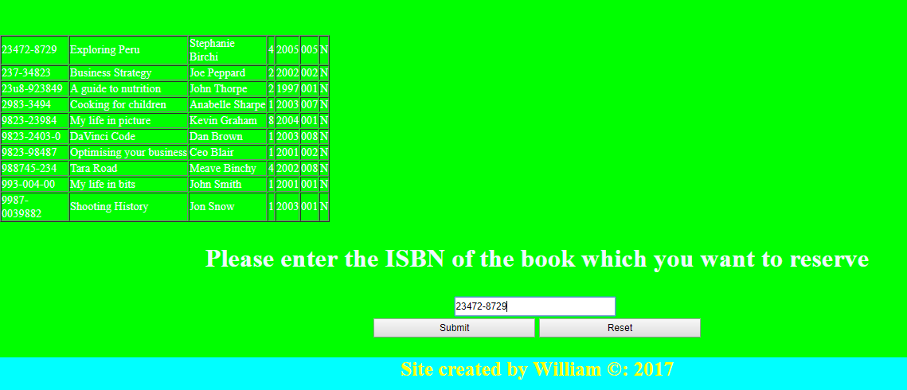

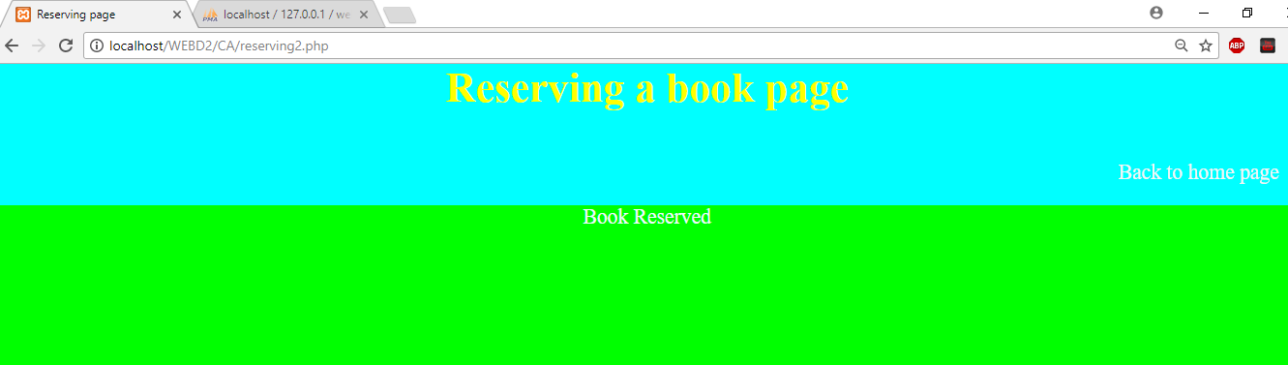

1. Reserved.php (code first then webpage)

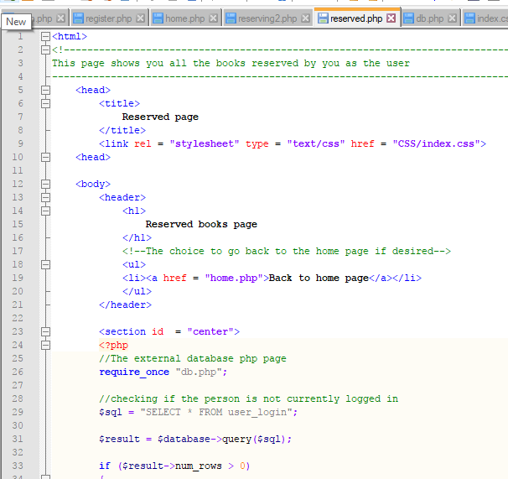

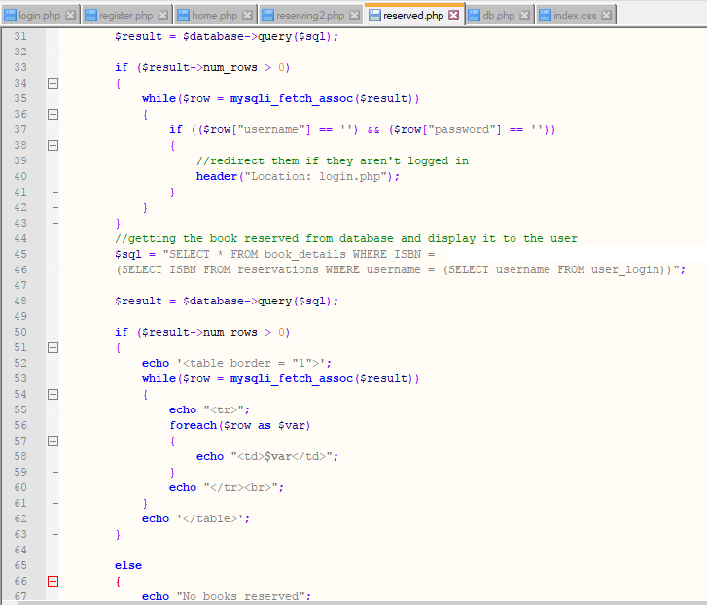

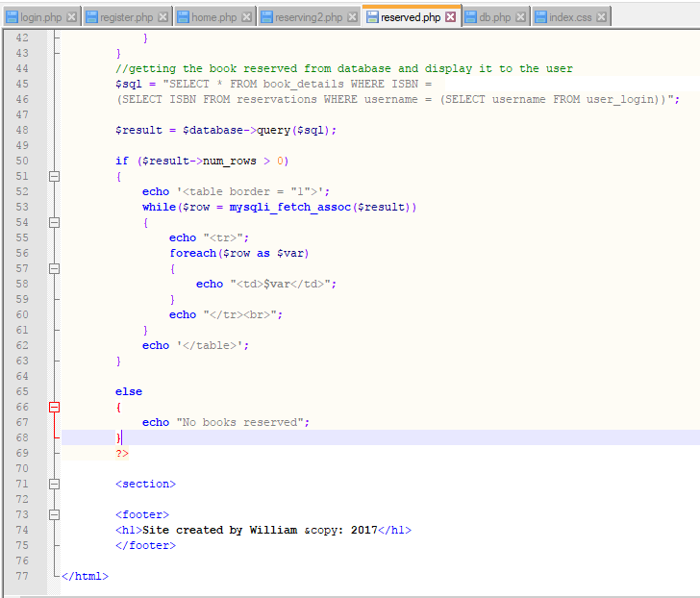

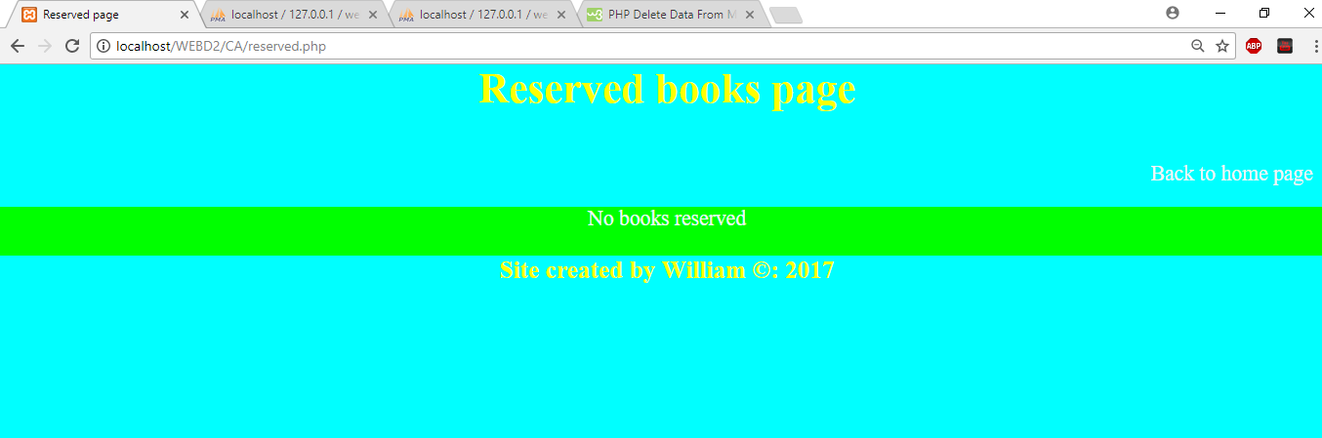

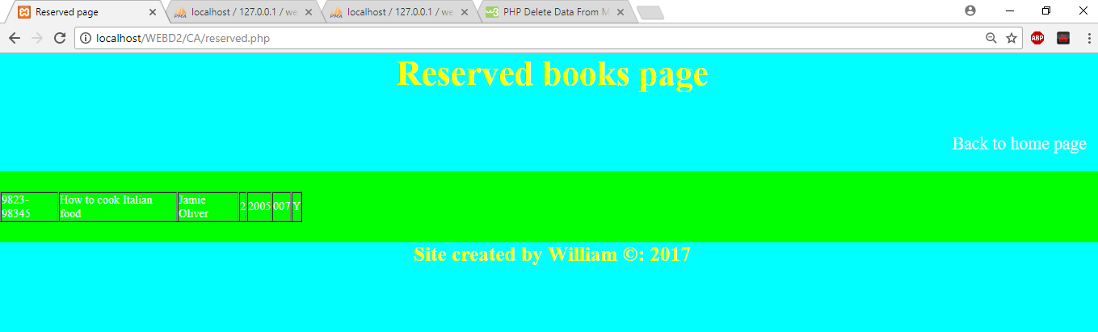

1. Db.php

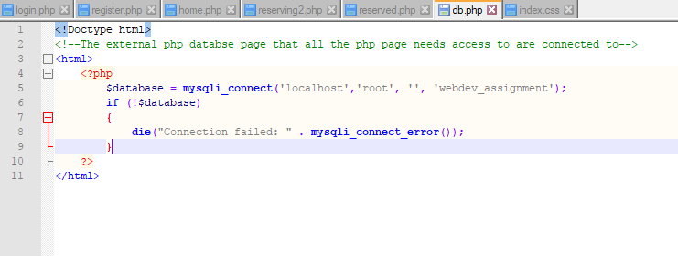

1. Index.css

